CSX Device Testing Document

Device: SX400  
Tested by: Matt Steiner   
Begin Date for Testing: 9/13/19  
Completion Date for Testing: <Completion Date>

Test the following (add screenshots where applicable):

* + 1. Basic install (including driver).  
        9/13/19
    2. Discovery testing. Plug/Unplug. Let sit overnight, still connected?  
       *Plug Test* 9/13/19  
       *Overnight Test* <Status and date of completion>

*Unplug Test* 9/13/19

* + 1. Web registration (with membership data transfer).  
       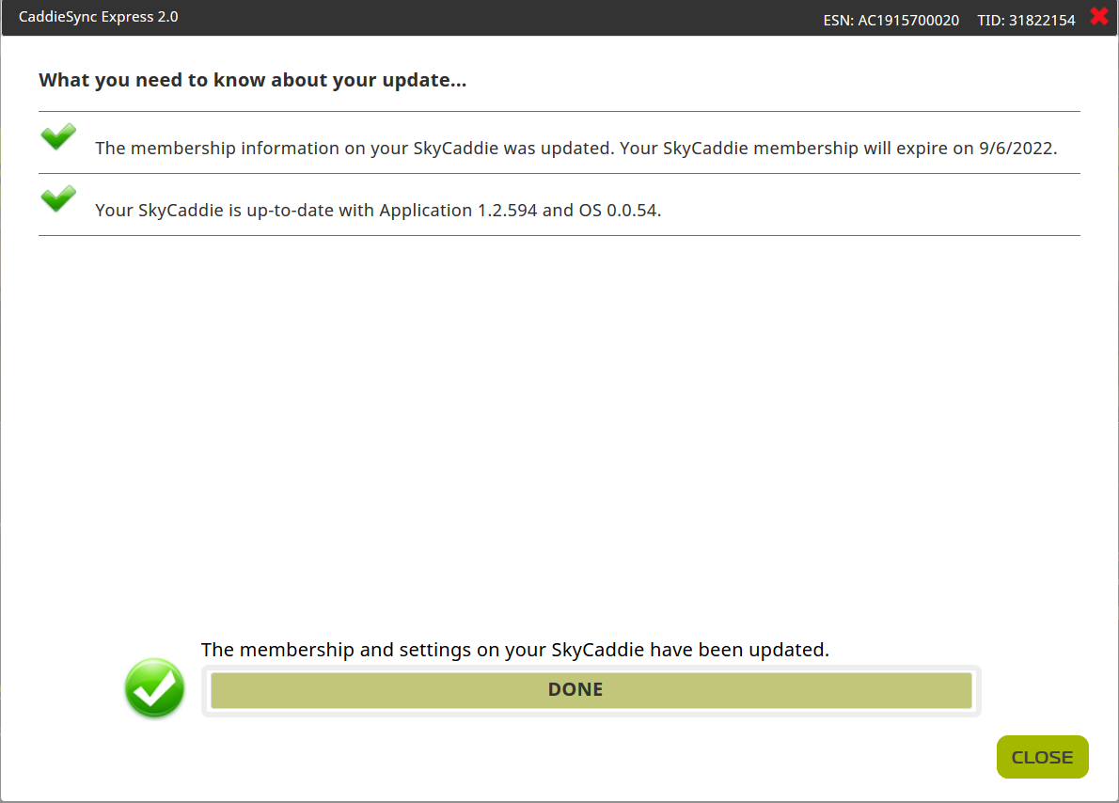
    2. Web App Update  
       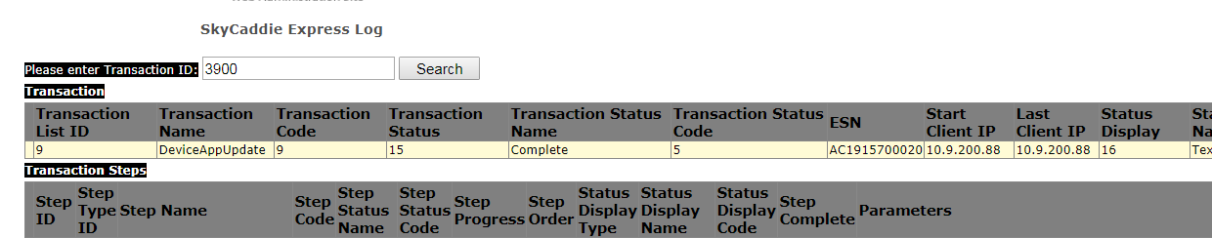
    3. Web Boot Update  
       Part of App update
    4. Web favorite course download.  
       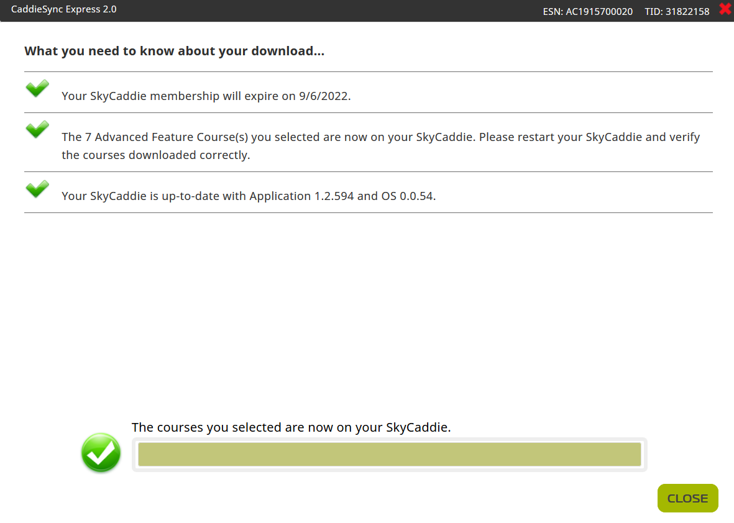
    5. Web preload course download.

<Status and date of completion with screenshot of transaction>

* + 1. Round data sync  
       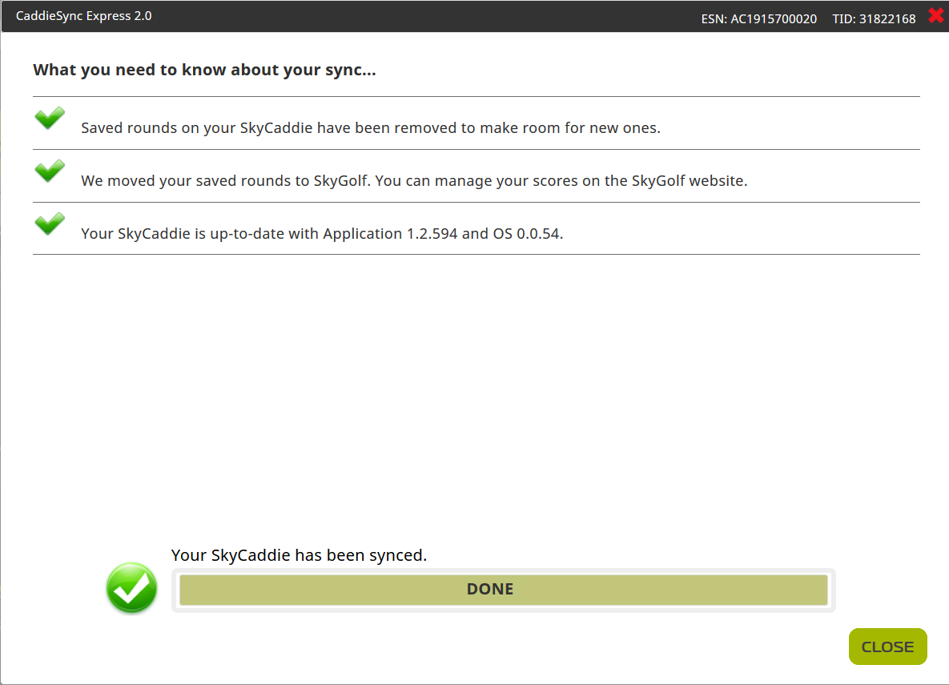
    2. Tag Data Sync  
       N/A
    3. Double click Membership.  
       Verified 9/17/19
    4. Double Click Favorite Course  
       Verified 9/17/19
    5. Double Click App Update  
       Verified 9/13/19
    6. Double Click Boot Update

Part of app update